User guide:

1. It is the Front Page of the website. The left column indicates all the applications, and the right side demonstrates all the information for the corresponding application

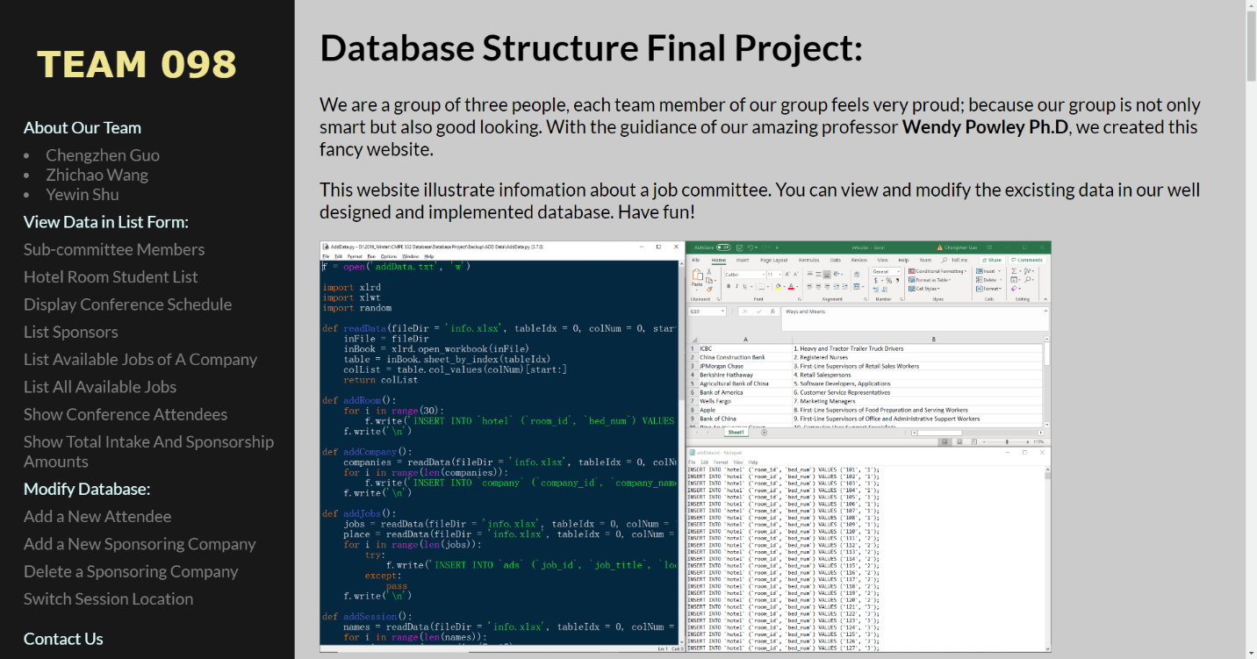

1. 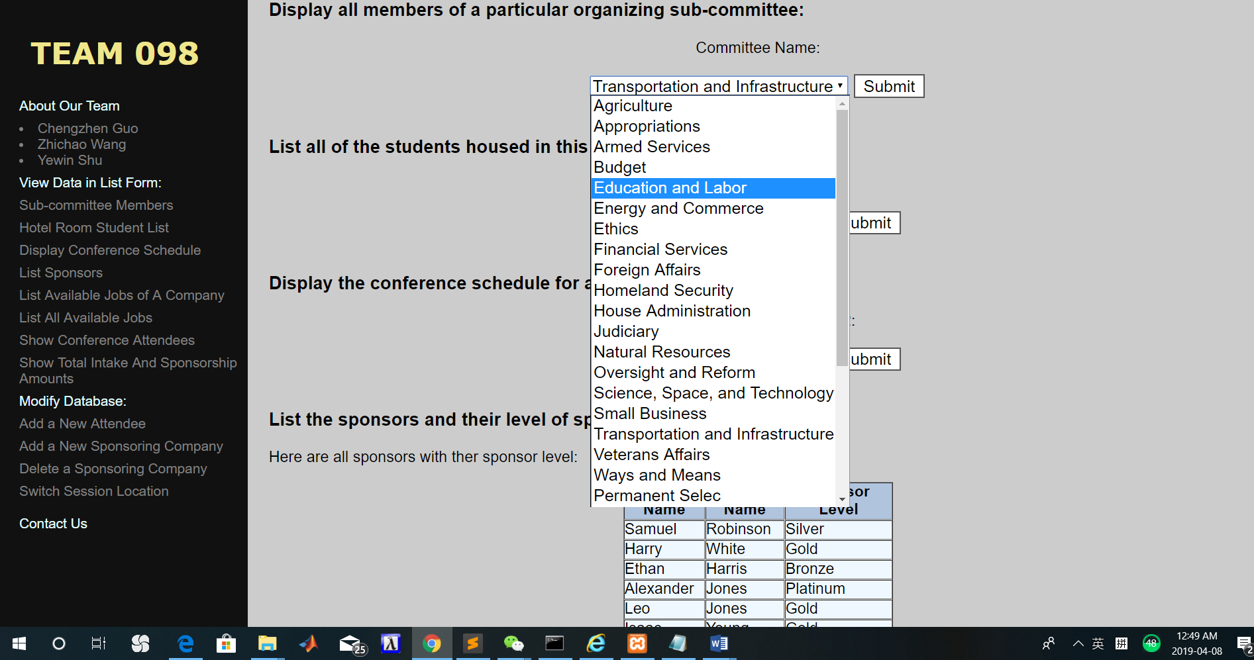User can choose the following sub-committee from the drop box to view the sub-committee members.
2. 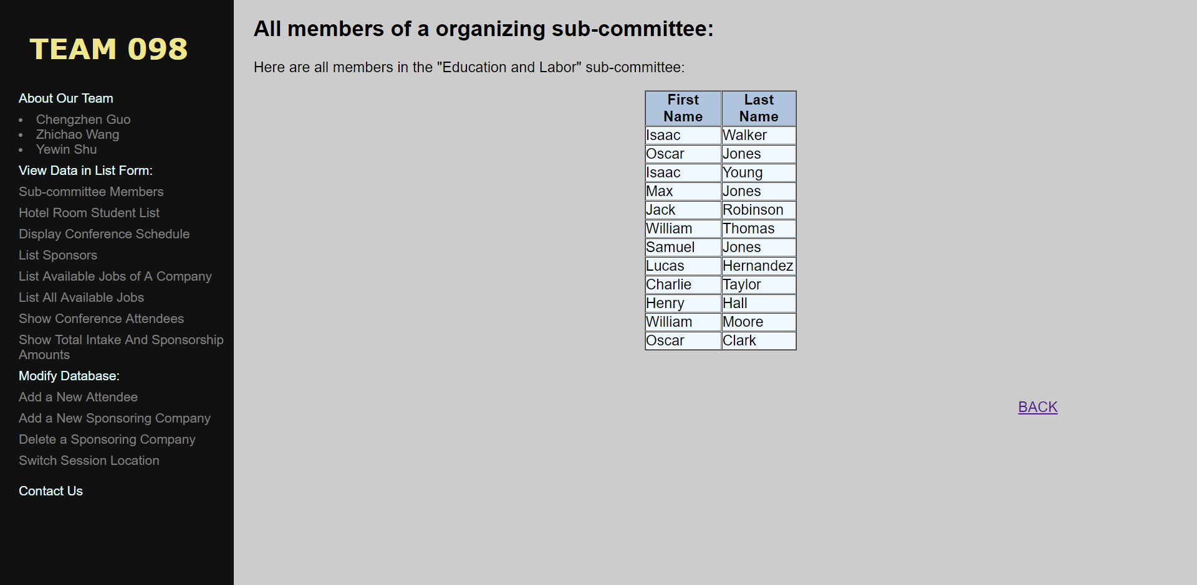When user selects one of the options from the drop box, the table of the sub-committee member are demonstrated as below.

User can return to the main page by clicking on this button

1. 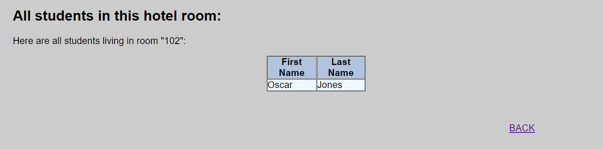User can enter a room number (101-130) to see which student is living in this room.
2. 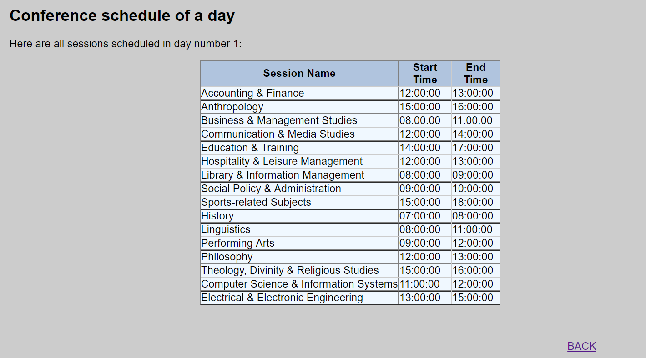User can view all the conference schedules for either day 1 or day 2. If user choose an invalid day, an empty table will be demonstrated.
3. 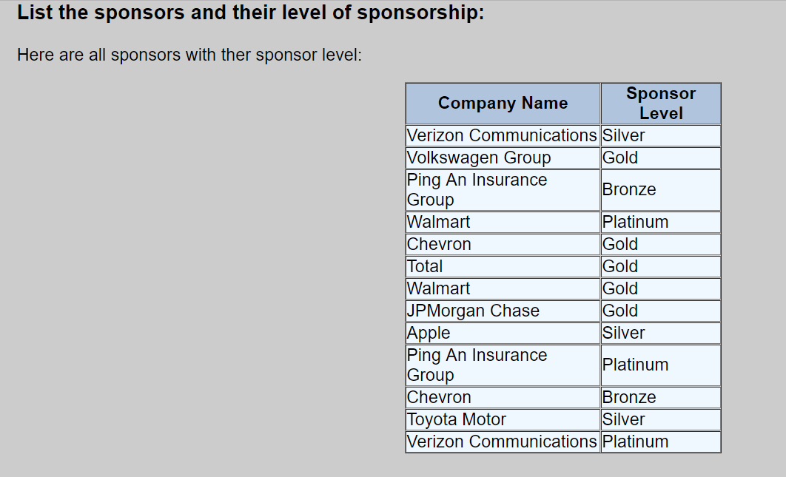User can view all the sponsors and their level.
4. 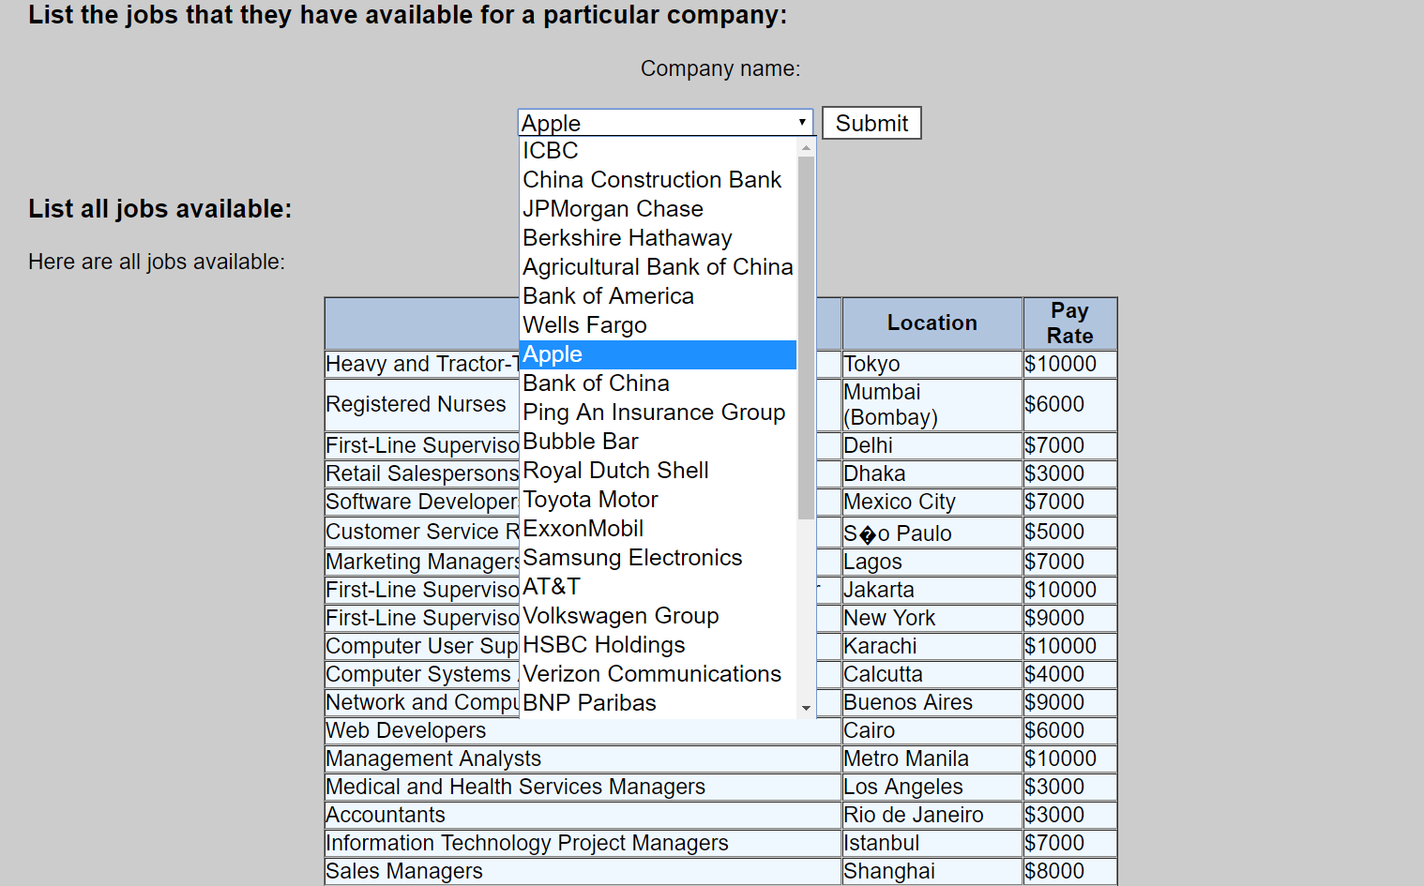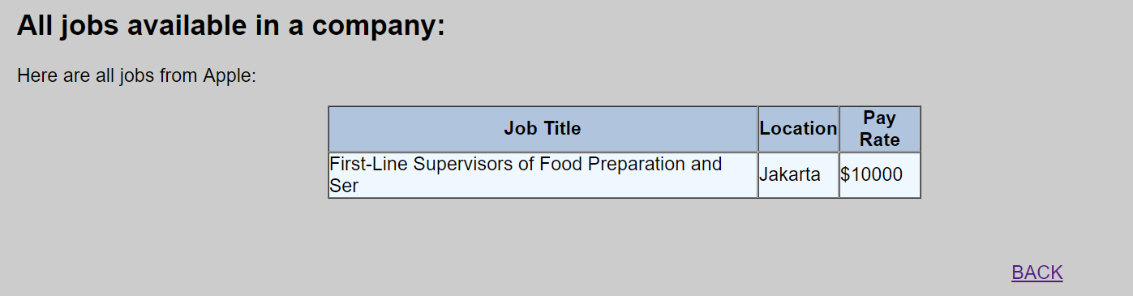User can choose one of the companies from the drop box to view all the jobs available:
5. 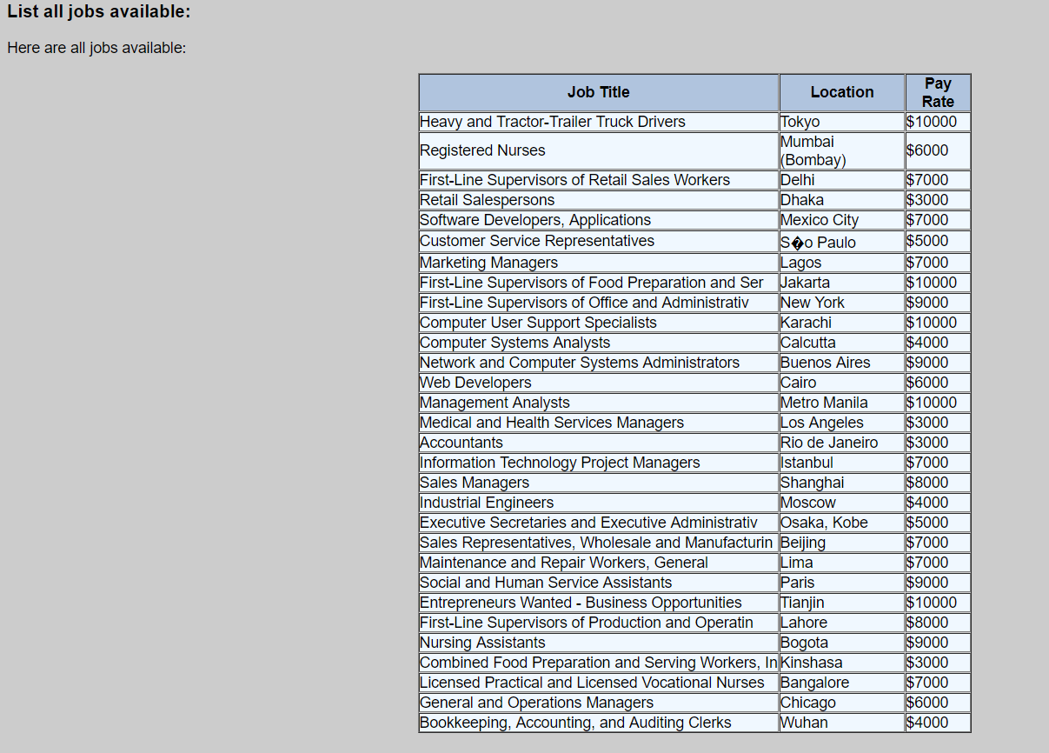User can view all the available jobs
6. 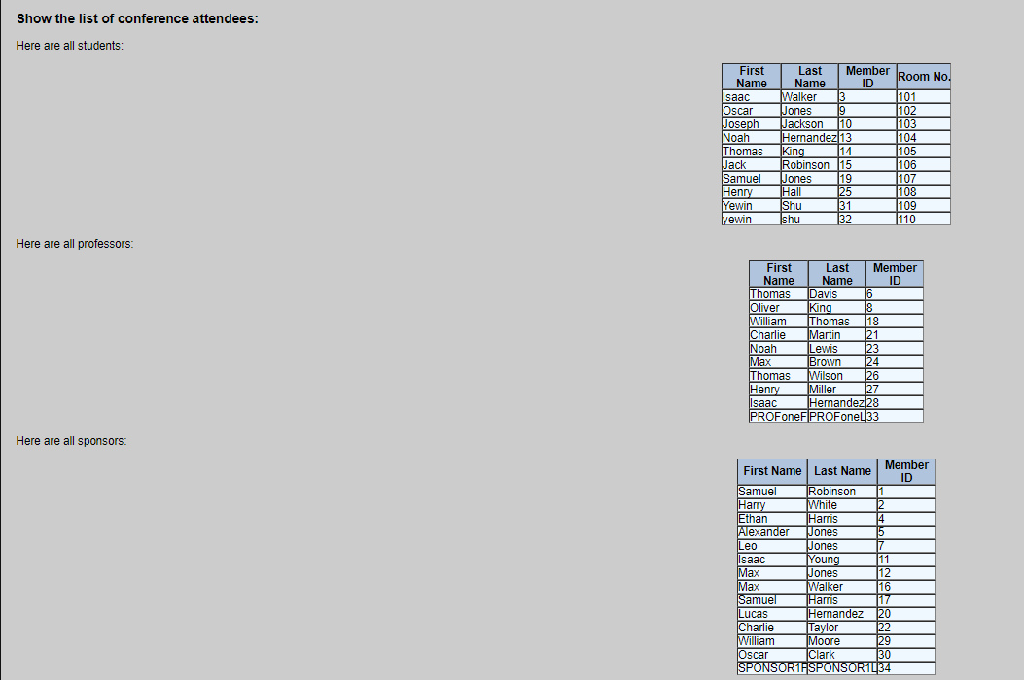User can view all the conference attendees
7. 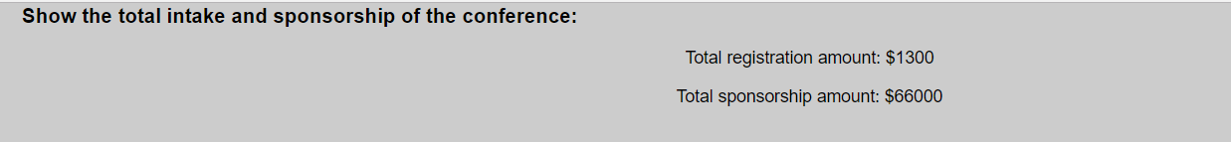User can view the total intakes of the conference.
8. 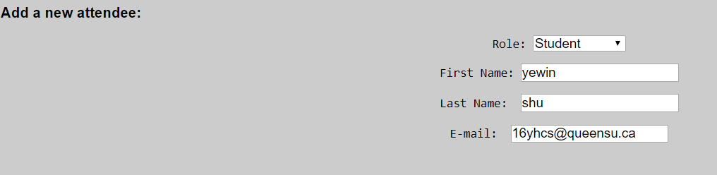User can insert a new attendee into the data. If user inserts a student, then the student will be arranged to a first available hotel room.

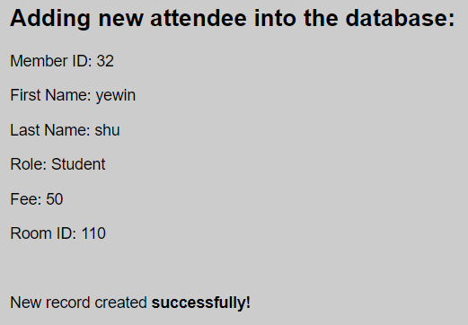

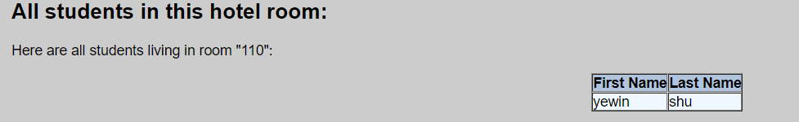

1. 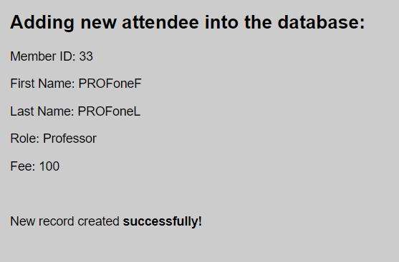If user inserts a professor, then the professor will be added. 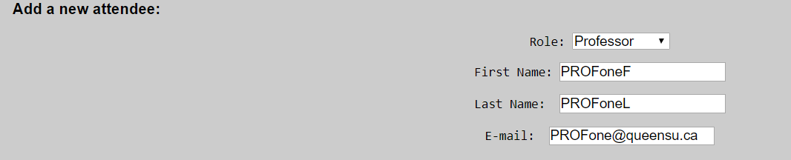
2. 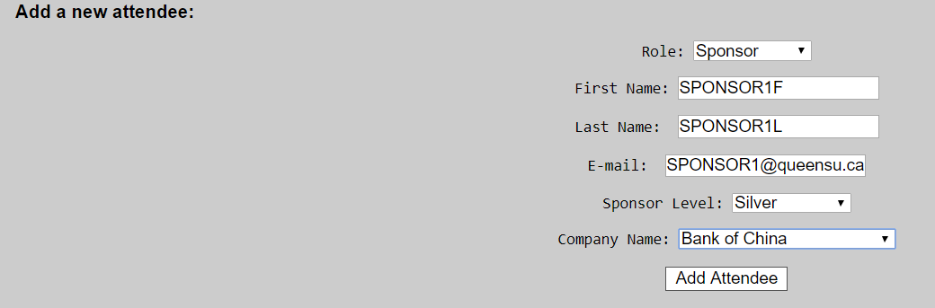If user inserts a Sponsor, user can choose the sponsor level and the company name.

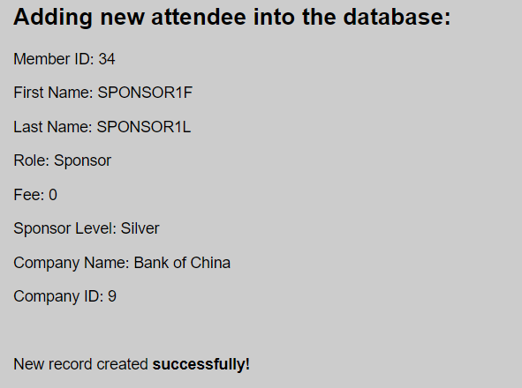

1. Add a new sponsoring company.



1. Delete a sponsoring company.



1. Switch session location

